**Task 8 – Professional Exposure**

* **Challenging Operation**: - Integration of Financial Data of 5 years from SAP 4.7 to SAP ECC6 within a Time span of 30 days and to Go Live on the Current Transaction after 30 Days
* **Summarize the issues in the Operation using “Lucid” Customer Problem Statement Template**

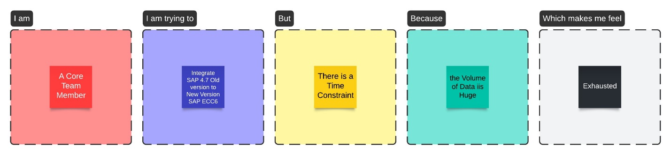

* **Solution for the Above Statement**: The Solution is to Hire an extra Resource Internally for Verifying the Data through Software Tools which will maintain the Data Integrity and Tallying with the Earlier Software Data by comparing the same. Due to this Model have completed successfully the Integration within the Time Frame and have got a “Spirit Award” for the same.

